PROJECT TITTLE

PASSWORD VERIFICATION

B.S. (SE)
Second Year Semester Project Report

Submitted by:
KANZA BATOOL 2126423
MOMNA ATTARI 2126436
NASHWA SHAHID 2126439
Submitted to:
MISS TOOBA KAZMI

June 2022

Department of Computer Science and Software Engineering

Jinnah University for Women
5-C Nazimabad, Karachi 74600

Table of Contents

Project Summary 1
Algorithm 2
Project Flow 3
Code Explanation 4
Screenshots 5

Project Summary
Our project is password verification .In this project user can register or log in the system. This project is based on hashing .
If user select register then user can write user name and password then this password convert into hash . file will be created as user name and the inputs ( username, password) and hash password will save into that file.
If User select login then user will write their registered username and password , username will check from files if it correct system check password that stored in file if incorrect it shows invalid username or incorrect password. if both are correct then login will be done.

GitHub Link
https://github.com/kanzabatool3002/password-verification.git
ALGORITHM

Step 1: Start
[Register]
Step 2: write username and password
Step 3: hash password using SHA 256
Step 4: Create file as username
Step 5: store Username , password and hash password in Username file
[login]
Step 6: write username1 and password1
[verify]
Step 7: hash password1 using SHA256
Step 8: if username in list_of_files, then
Step 9: open file
Step 10: if hash password1 is true, then
Step 11: login successful
Step 12: else
Step 13: invalid password
Step 14:else
Step 15: user_not_found
Step 16: Exit

Project Flow

Start
Select your choice
Username
Username
Password
Password
Check Username
Check hash Password
End
Login
Register
Hash password
User not found
Invalid password
Login successful
Save Username , Password and hash password in User name file
True/ False
True/ False
false
true
false
true
Hash password

Code Explanation

Designing window for registration

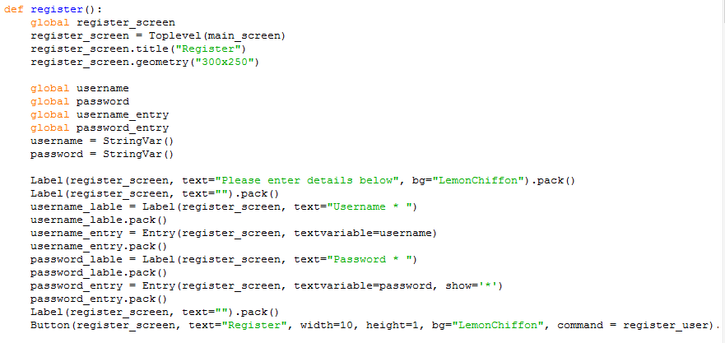

Designing windows for login:

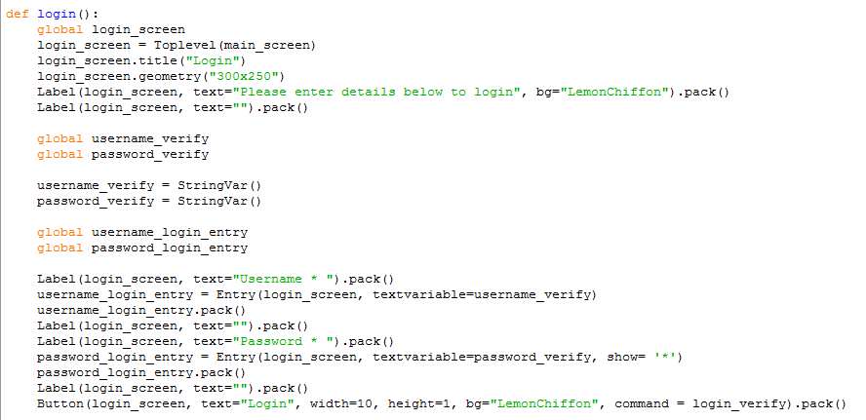

Implementing event on register button

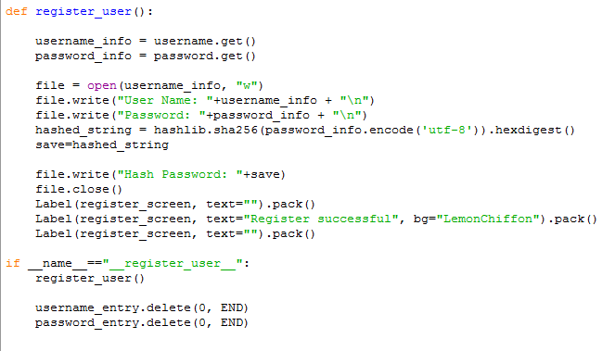

Implement event on login button

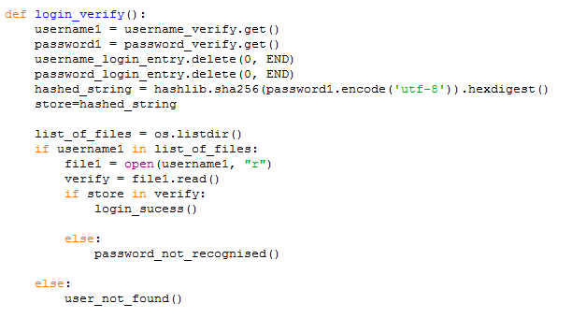

Design popup for login successsful

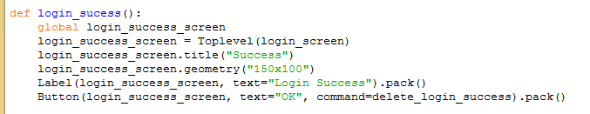

Designing popup for login invalid

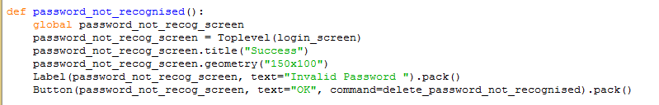

Designing popup for user not found

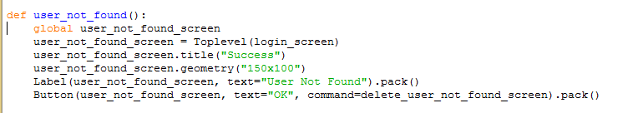

Deleting popups

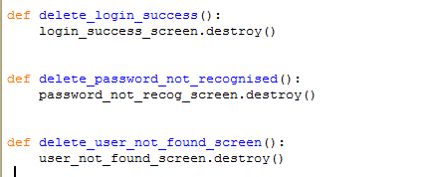

Designing main window

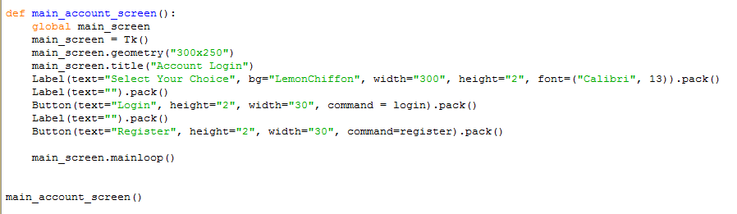

Screenshots
Main window
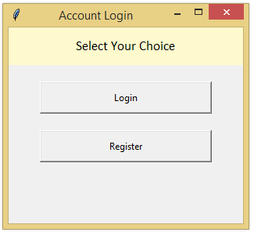

Registered window
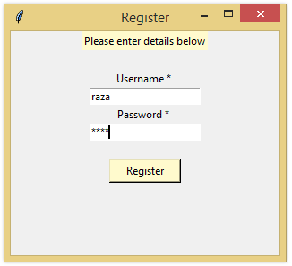

file
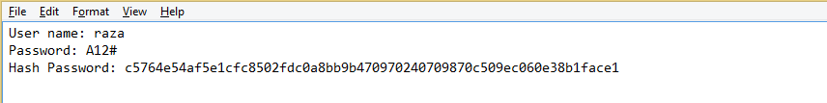

Login window
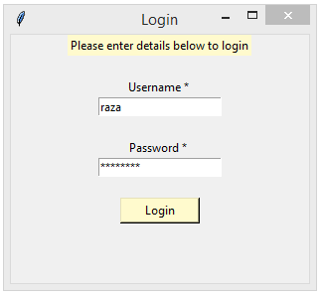

Invalid password popup
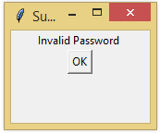

User not found popup
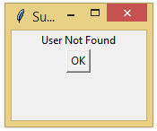

Login successful popup
